BATTLE AGAINST INVASIVE WEEDS IN LAKE TAHOE
WILL GAIN NEW SCIENTIFIC DATA THIS SUMMER

Test sites will be closed to water activities in the Tahoe Keys

March 3, 2022 (South Lake Tahoe, Calif.) – Scientists will gather new data points and information this spring and summer in the long-waged battle against aquatic invasive weeds in Lake Tahoe when the controlled methods test begins in the Tahoe Keys lagoons. The results will help determine long-term solutions for the lagoons and Lake Tahoe. (https://www.keysweedsmanagement.org/cmt-project)

The Control Methods Test (CMT), which was unanimously passed by the Lahontan Regional Water Quality Control Board and the Tahoe Regional Planning Agency Board, will use stand-alone and combined use of various approaches including targeted herbicides and UV-C light to reduce and control the abundant growth of invasive and nuisance aquatic weeds in the Tahoe Keys west lagoon and Lake Tallac areas.

To preserve the integrity of the tests and results, the Tahoe Keys Property Owners Board of Directors adopted an emergency rule restricting boat and water activities in the treatment areas from April 18 to as late as mid-July 2022. The homeowners of the Keys have already made a significant financial investment in the battle to keep the lagoons clear of weeds and the CMT itself will cost the TKPOA up to $3 million. The start of the tests is slated for April, but that will depend on water levels and other natural factors.

“The CMT will help determine the most effective, integrated management methods that will greatly reduce the impacts and threats of invasive aquatic plants on Lake Tahoe as well as improve management in the Tahoe Keys lagoons,” said Dr. Lars Anderson, an aquatic ecology/invasive species specialist and former affiliate of the University of California, Davis Weed Science Group. “It’s been a long road to get to this point, and time is of the essence. We need this data to combat this problem and while the herbicide concentrations to treat the weeds will be at levels safe to humans, pets, fish and wildlife, stopping water activities inside the treatment areas is necessary to protect the validity of the CMT.”

To help with the inconvenience the test period will bring for the homeowners in the treatment areas the TKPOA board is making accommodations. Boats and other watercraft that are already docked in the treatment areas prior to April 18, 2022, may remain moored but can’t be operated during the test period. There will also be no swimming, pets, sailboats, personal watercrafts, kayaks, canoes or stand-up paddleboards allowed in the test areas as they could compromise the results of the entire test. Water access for homeowner kayaks, stand-up paddleboards and similar items will be allowed at the TKPOA ramps in non-restricted areas on Christie Drive, Wedeln Court, Traverse Court and Slalom Court. The TKPOA is also waiving regulations against street and driveway parking for boat and trailer storage during the test period. Homeowners will have 10 days from the end of the test to relocate any boats and trailers from the streets. The TKPOA is also gathering a list of homeowners with docks outside the test areas who are willing to offer dock or mooring space to affected homeowners’ boats.

The test areas will be clearly defined in the waterways with prominent signage and turbidity curtains. At a recent open house on the parameters of the test, many TKPOA members acknowledged the need to work together as a community to ensure the CMT is successful and move toward a comprehensive solution to invasive weeds and overall water quality.

Since the 1980s, TKPOA has invested millions of dollars to combat AIS and worked with prominent regulatory bodies and the League to Save Lake Tahoe on numerous concepts including weed harvesting, fragment collection, bottom barriers, bubble curtains, and supported research on other new methods. The agencies have mobilized their staffs in support and matched the TKPOA investment.
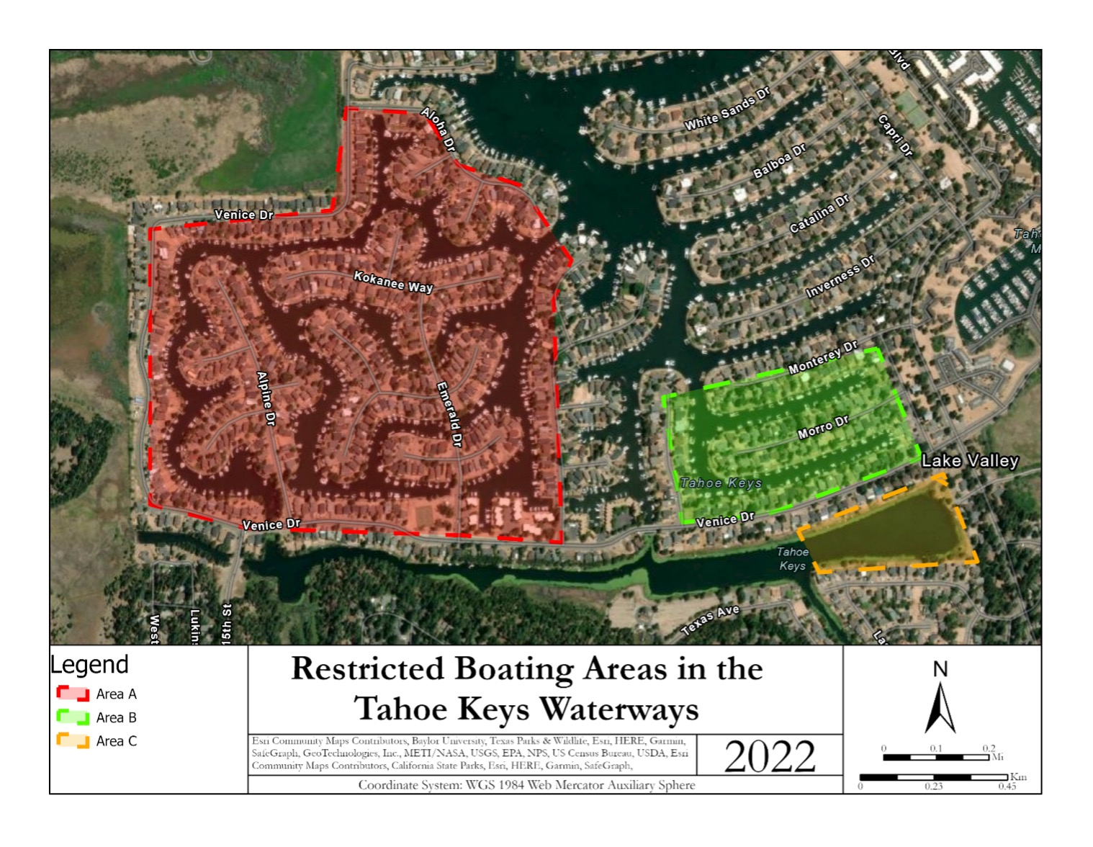

Media Contacts:
Christina Proctor, christina@weidingerpr.com
Phil Weidinger, dinger@weidingerpr.com
Weidinger Public Relations, 775-588-2412
####

About Tahoe Keys Property Owners Association
The Tahoe Keys Property Owners Association (TKPOA) is a well-maintained and operated recreational-oriented residential association of 1,528 property owners on the shores of Lake Tahoe.

